What are "warm" and "cool" colors? What different feelings do they evoke?
Warm and cool color schemes are used in website designs in order to achieve emotions or create an atmosphere. Warm color schemes include red, orange, and yellow, which produce the emotions of vigor, excitement, passion, and warmth. Such colors can create exciting or urgent content on websites because red symbolizes urgency while orange stands for friendliness. Cool colors such as blue, green, and purple produce emotions of tranquility, trustworthiness, peace, and professionalism. Blue is widely used in businesses and technological websites since trustworthiness and reliability can be associated with it. Green is often chosen by health/wellness websites due to its association with wellness, nature, and harmony.
How does a color's effect change depending on the other colors nearby?
The impact of a certain color can vary according to what other colors are present around it in the picture; it is called simultaneous contrast. Some colors can seem either lighter or darker or warmer and cooler in relation to the colors surrounding them. Brighter colors gain more prominence when they are put against a background of darker colors. Meanwhile, softer colors can look more vibrant against neutral colors. The choice of contrasting colors such as blue and orange and red and green helps designers make important elements on a page stand out from others, especially buttons and headings. Similar colors tend to produce a pleasant and harmonious combination. It is important to choose the right color combinations for websites since they can affect people's reactions to particular pages.
What are some examples of the cultural differences related to color and meaning?
Colors can have multiple meanings according to the culture of the person who perceives them, a factor that should be taken into account when designing websites. White has positive associations in several Western cultures because it means purity, cleanliness, and weddings, but in many Eastern cultures, the meaning of the color is negative, implying mourning and death. While red has traditionally been used in the U.S. to convey love, passion, or even danger, in China, the color usually implies luck, joy, or happiness. Green, although often associated with nature, health, or new beginnings, can have political or religious implications in other contexts.

Name: The Daily Grind
Mood: The sharp contrast between the industrial greys and the energetic yellow creates a focused, disciplined atmosphere perfect for a solitary morning routine


Color Palette:
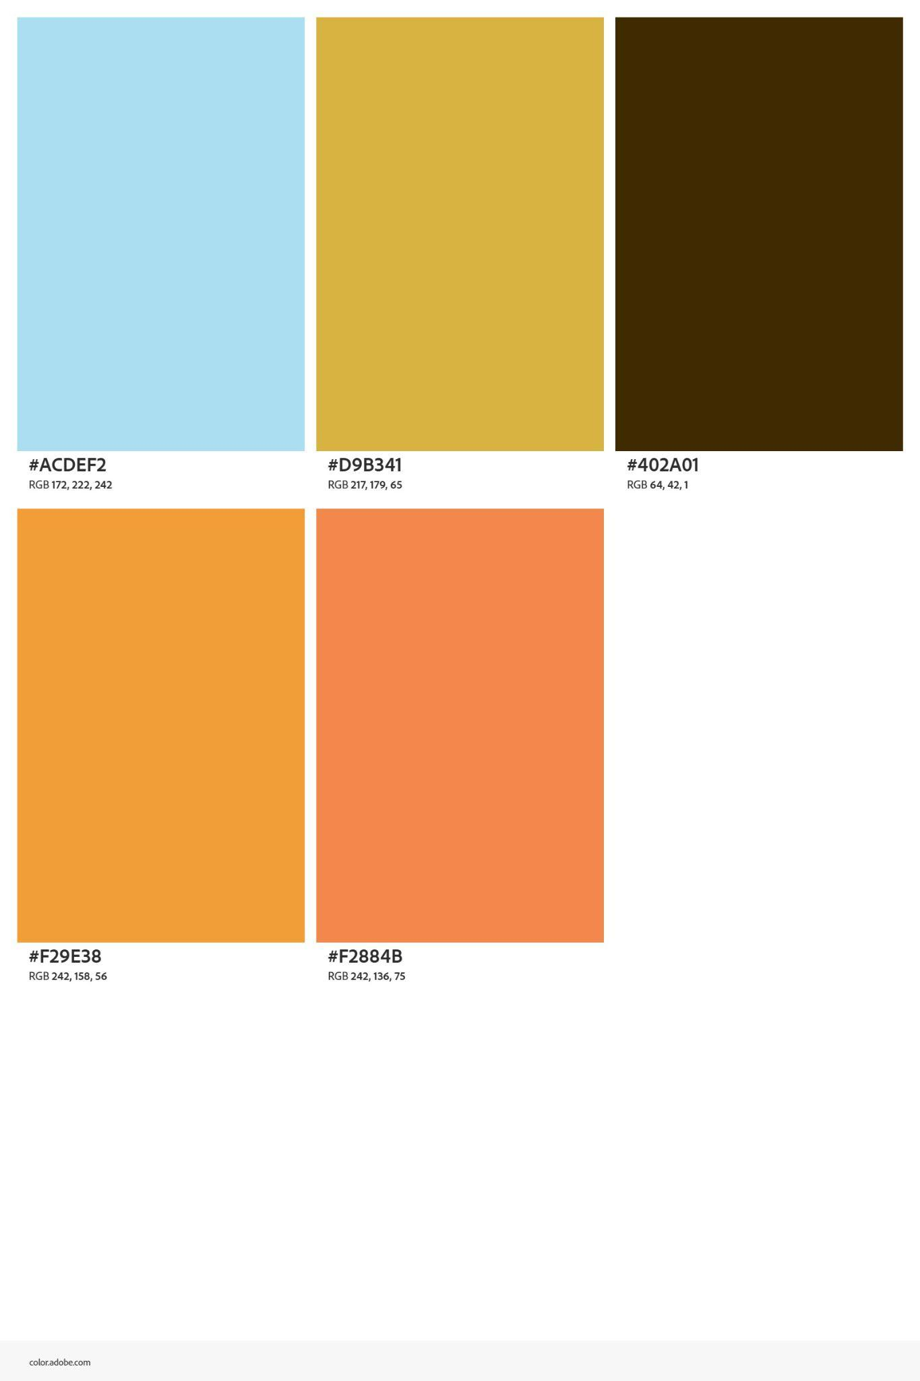

Name: Finally Catching My Breath
Mood: The cool, muted blues feel like a deep exhale, while the soft orange brings a touch of cozy warmth


Color Palette:
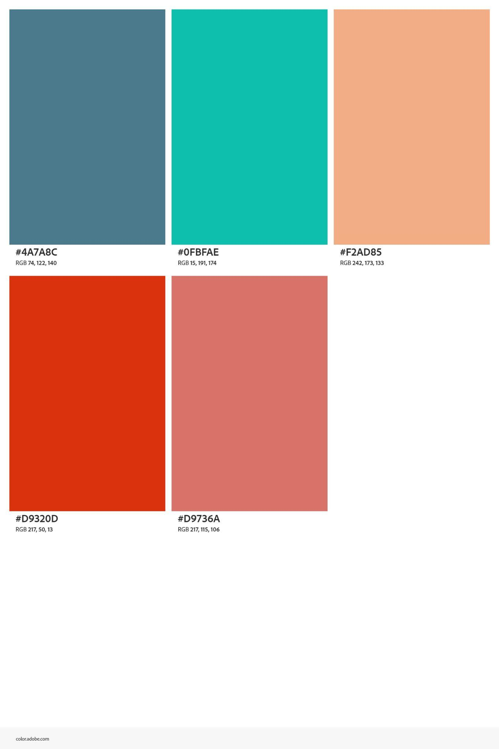

Name: The Hype Crew
Mood: The explosive neon pinks and bright sky blues create a high-energy personality that feels like a shared shot of adrenaline



Color Palette:
